PART 1: Data Analytics Fundamentals (Healthcare Context)
Task 1: Introduction to Data Analytics
1.What is Data Analytics in the healthcare industry?
Data analytics in healthcare industry means collecting, processing and analysing healthcare data to improve patient care, hospital operations, claim results, decision making, costs etc.

2.How can hospitals use data analytics to improve patient care?
Hospitals can use data analytics to improve patient care by
- Analysing patient history, lab reports.
- Compares patient data with similar cases
- Early detection of diseases
- Reducing risks
- Analyses patient appointments

3.List 5 data points a hospital collects daily.
- Patient health history
- Patient admission
- Patient vitals
- Billing
- Insurance
- Beds availability
- Available doctors and staff
- Medicines

Task 4: Descriptive Statistics
- Mean Treatment Cost 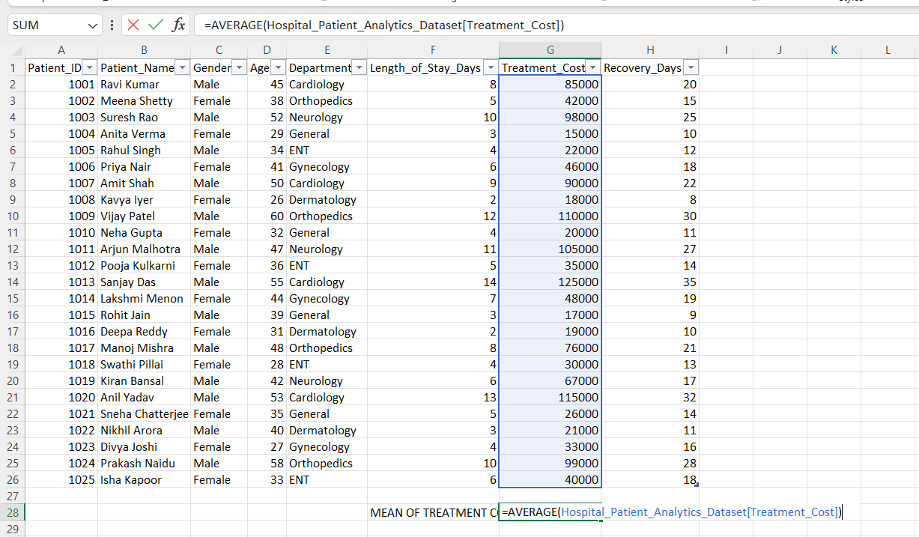
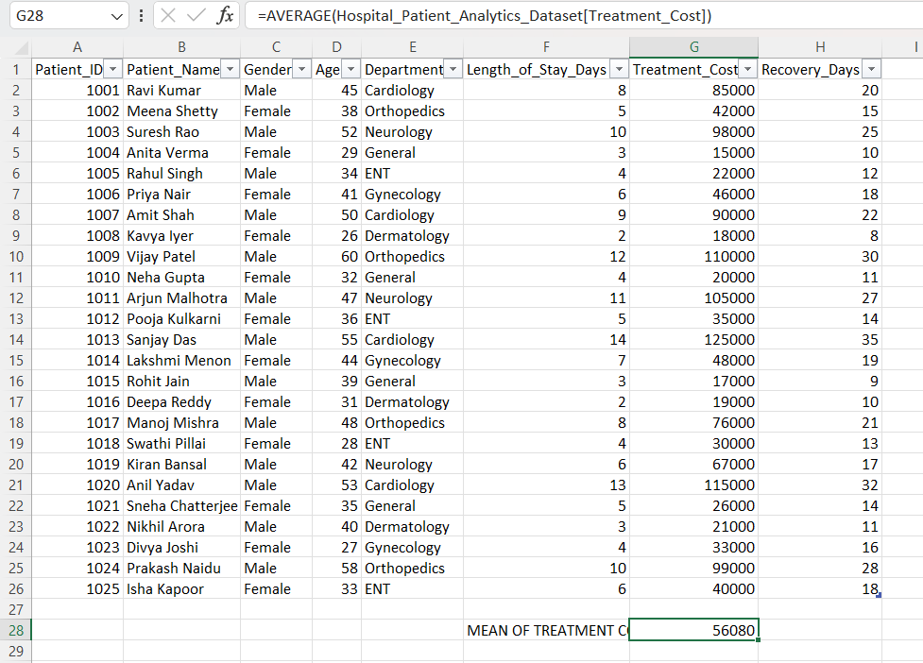
2.Median Length of Stay
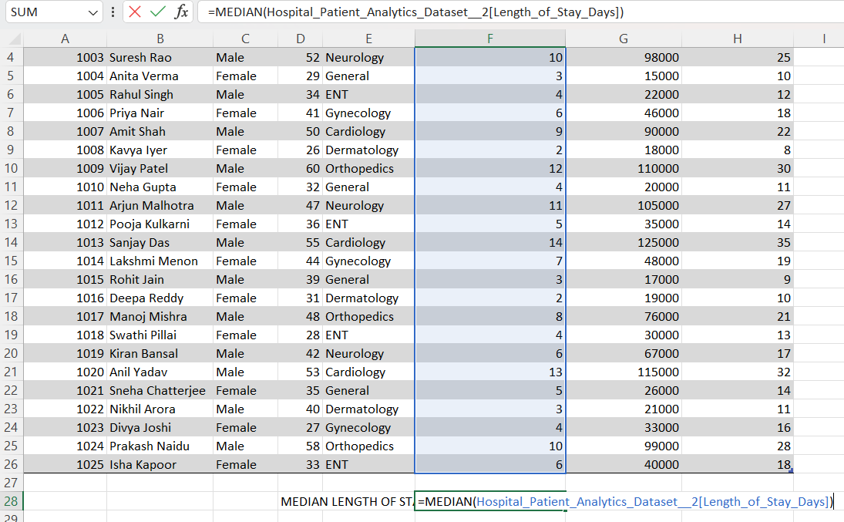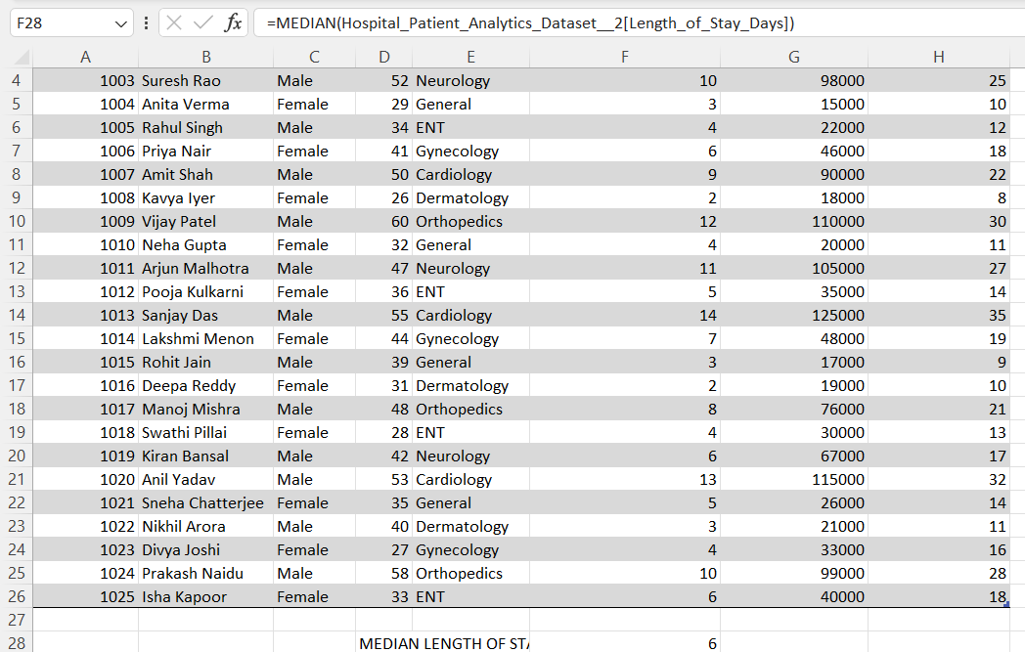
3.Mode of Recovery Days 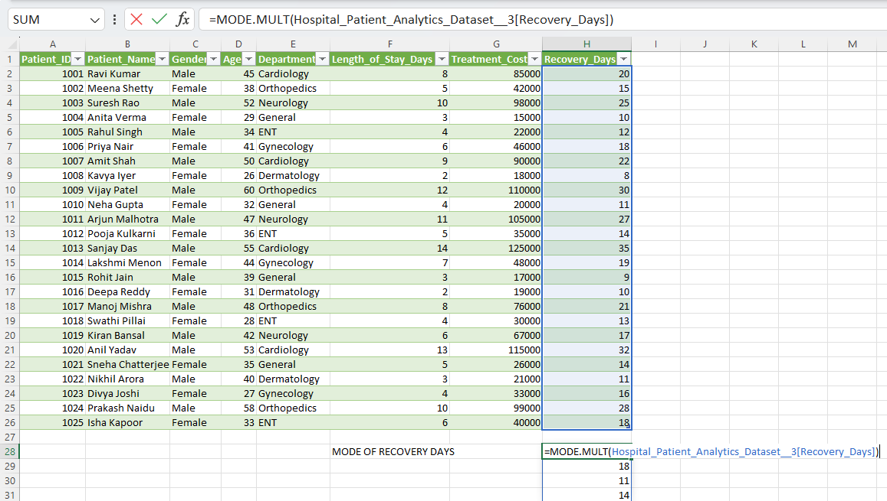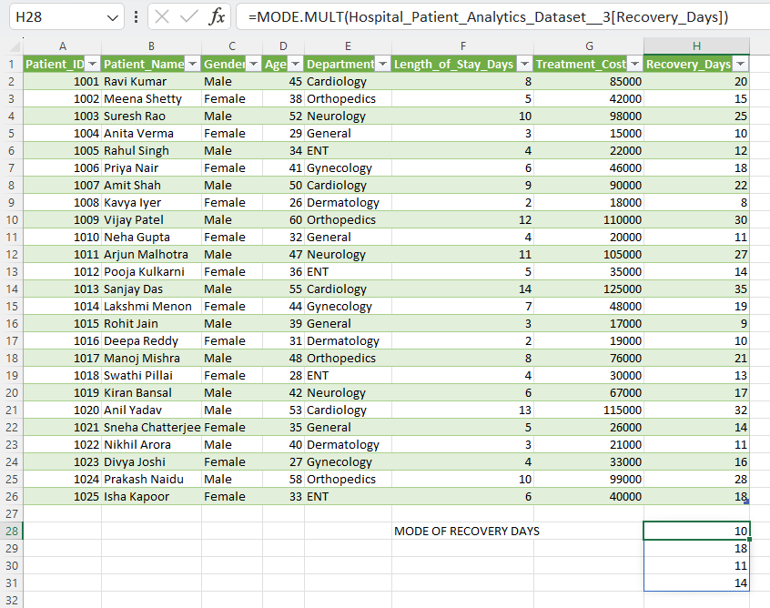
Interpretation Questions:
- Why is median preferred over mean in healthcare expenses?
Median is preferred over mean in healthcare expenses as mean is based on overall total expenses incurred by patients while median includes high, modern and low expenses incurred by patients.
Few patients will very high medical bills and few will have moderate to low medical bills, so considering median will be better as median is not effected by extreme values.
Median considers the middle value i.e.,50% of patients spend less and 50% spend more.

PART 4: Excel Formulae (Core Analyst Skills)
Task 7: Aggregate Functions
Calculate:
- Total Treatment Cost
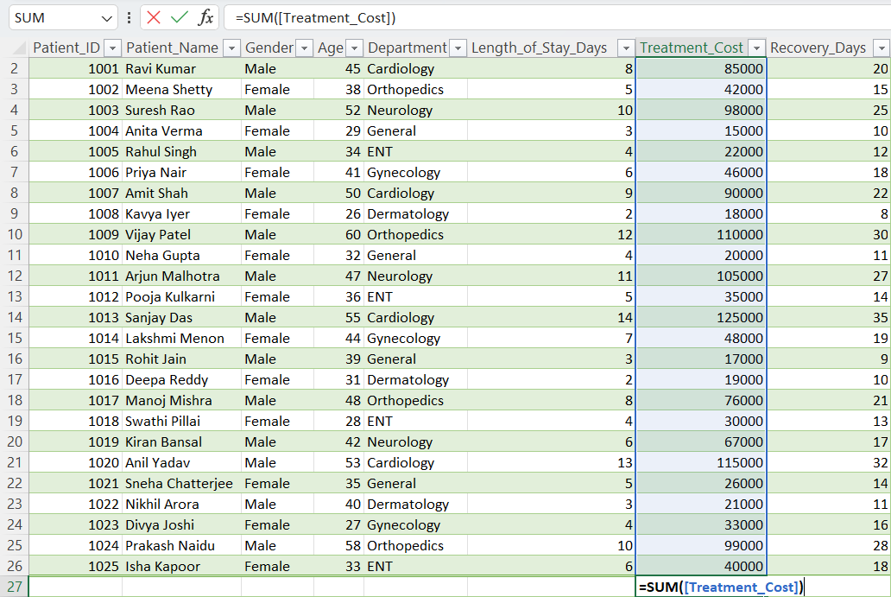
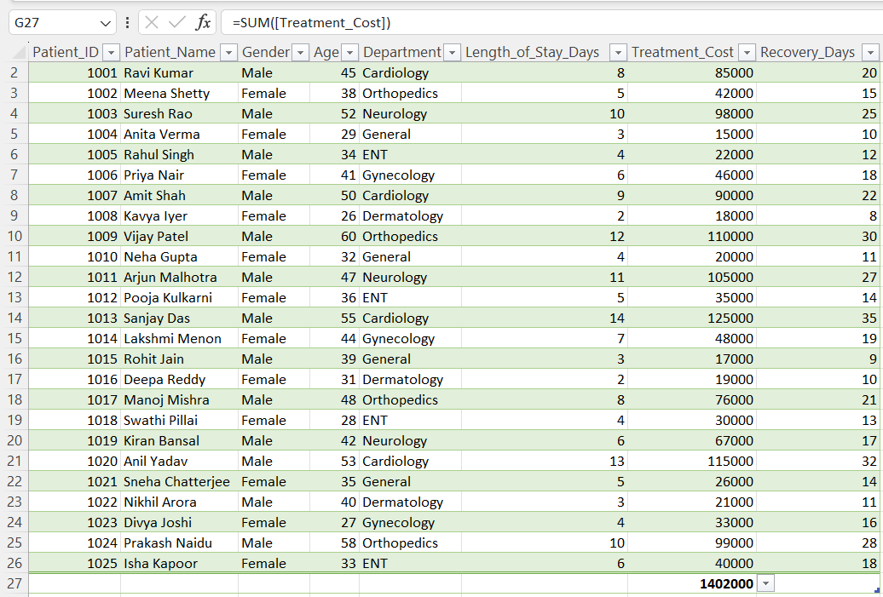

- Maximum Recovery Days
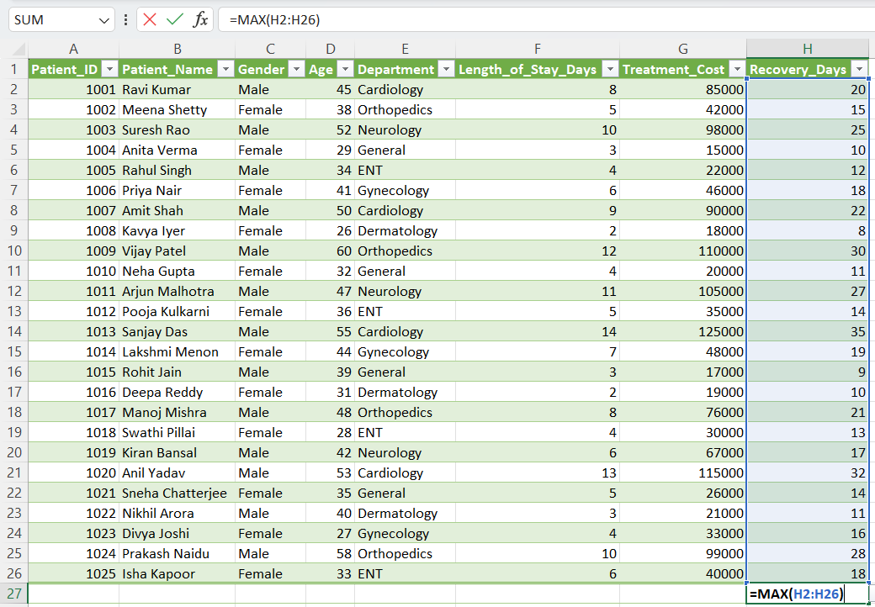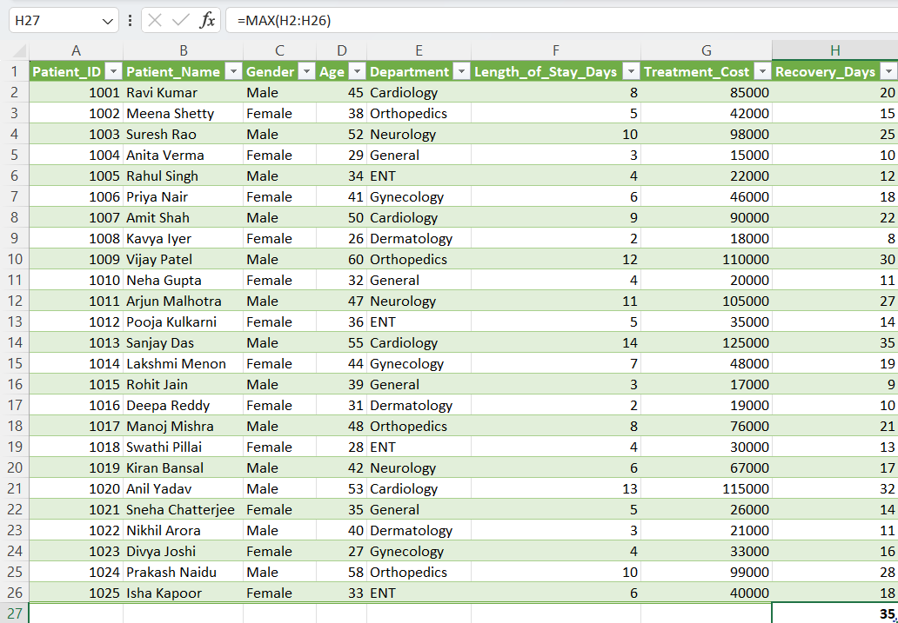
- Minimum Length of Stay
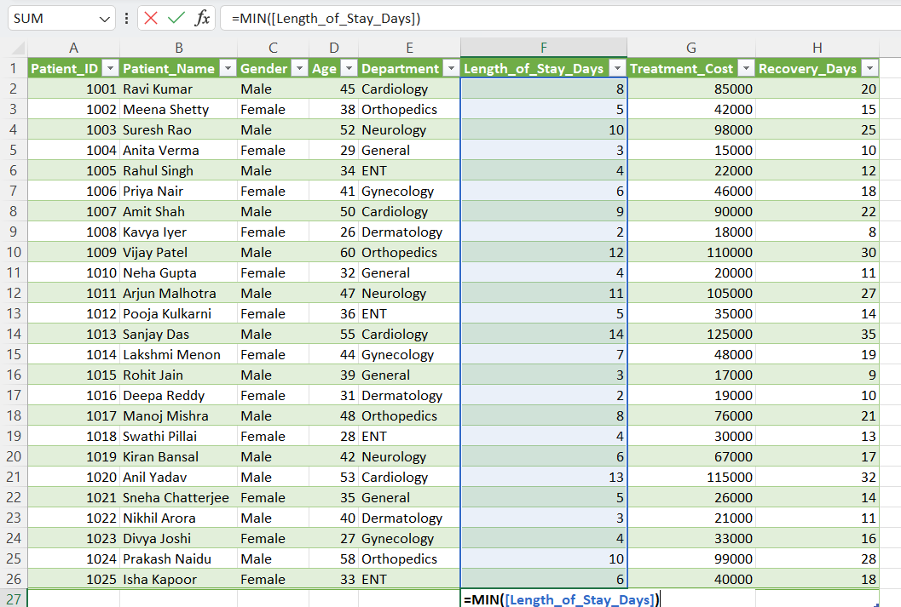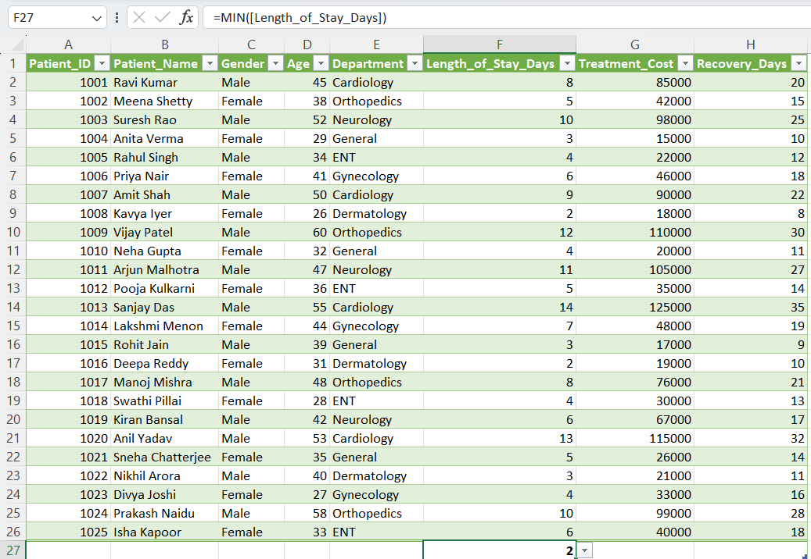
- Number of patients
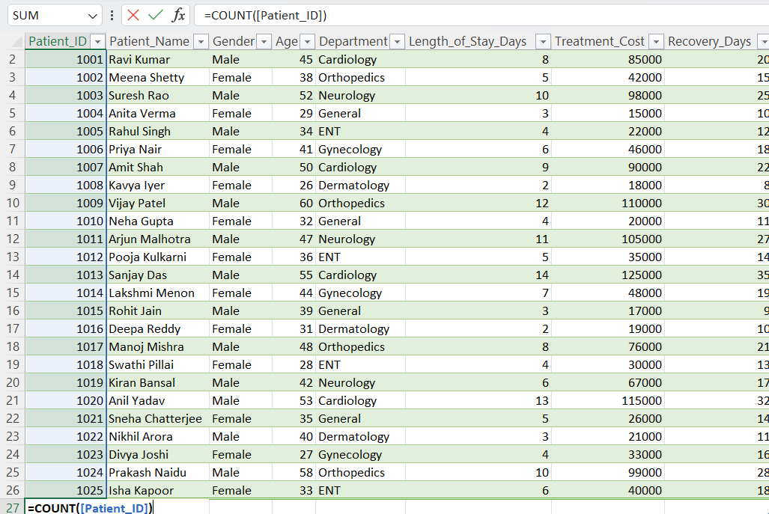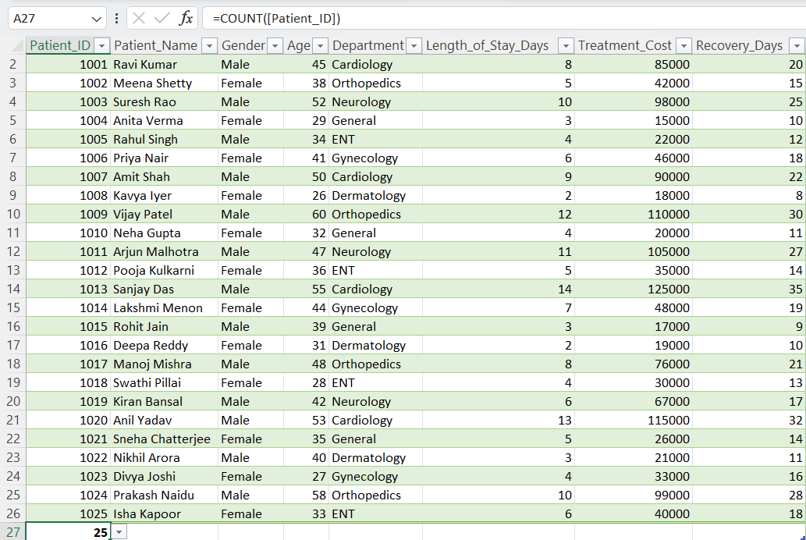
- Average treatment costs
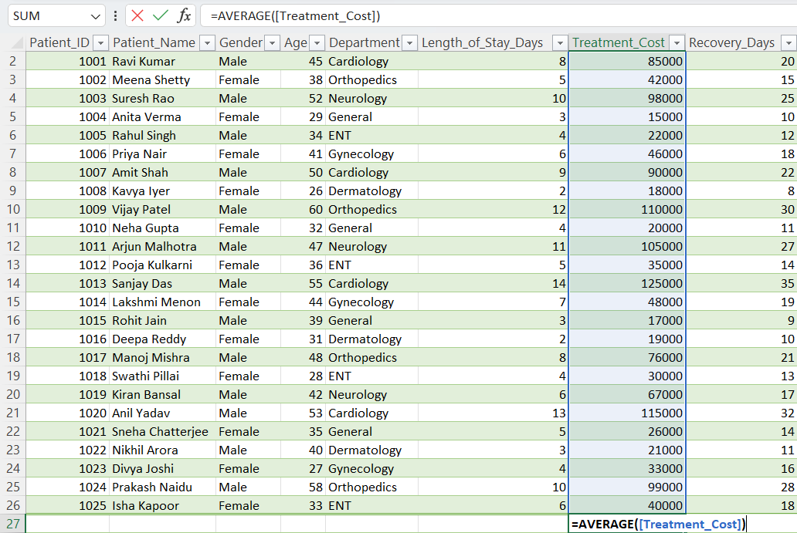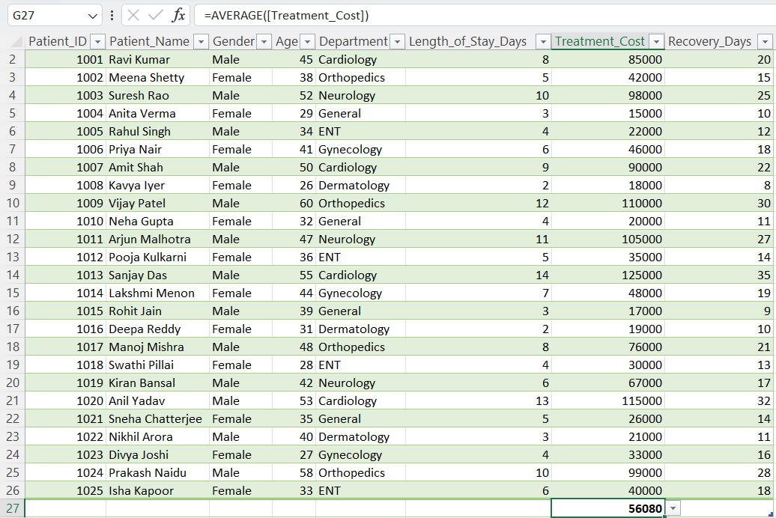
Task 8: Conditional Functions
  - Use IF(): High Risk if Length_of_Stay > 7
  - Normal Risk otherwise

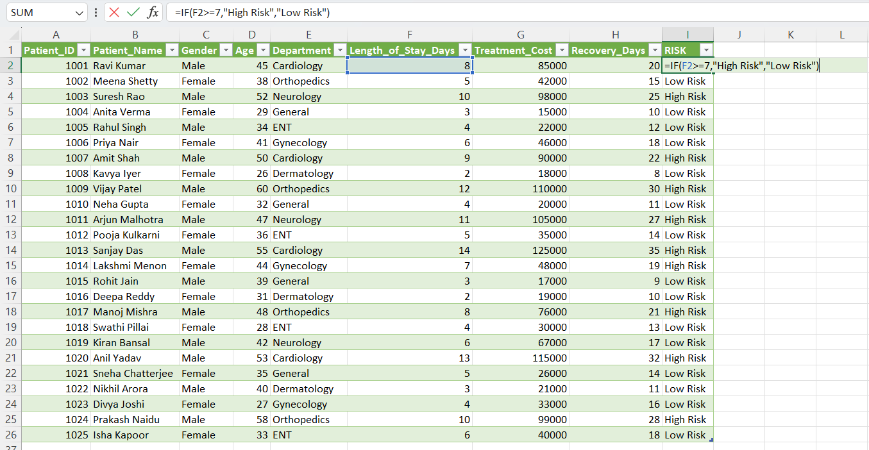

2.Calculate:
• Total cost for Cardiology
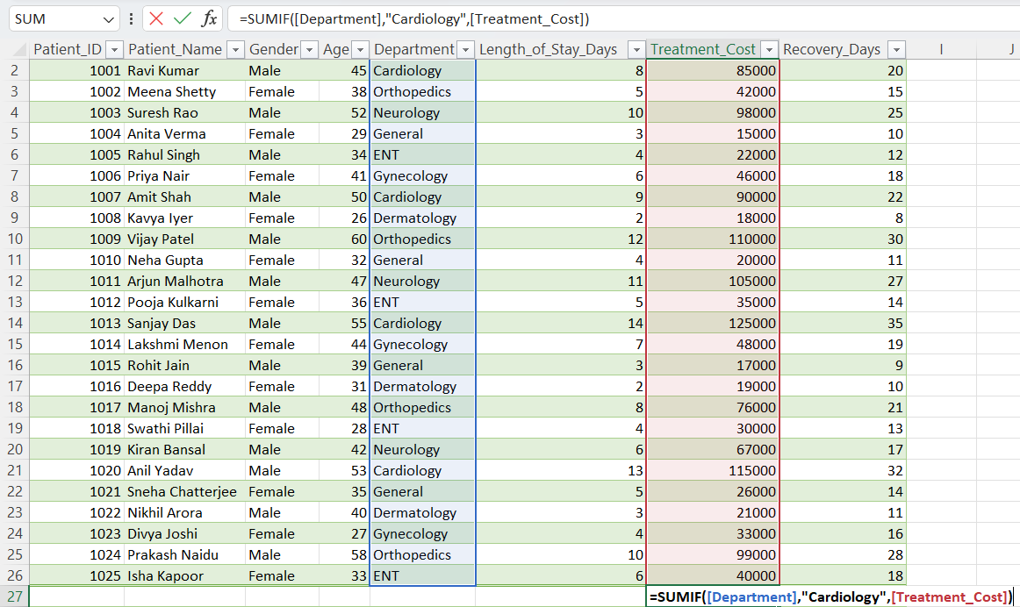
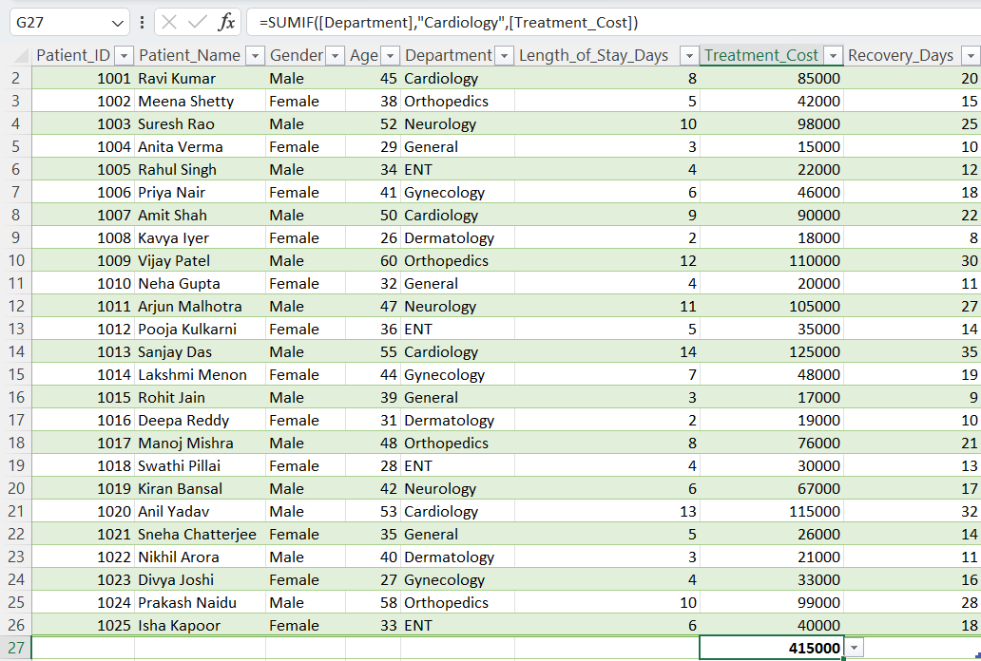

- Patients staying more than 5 days
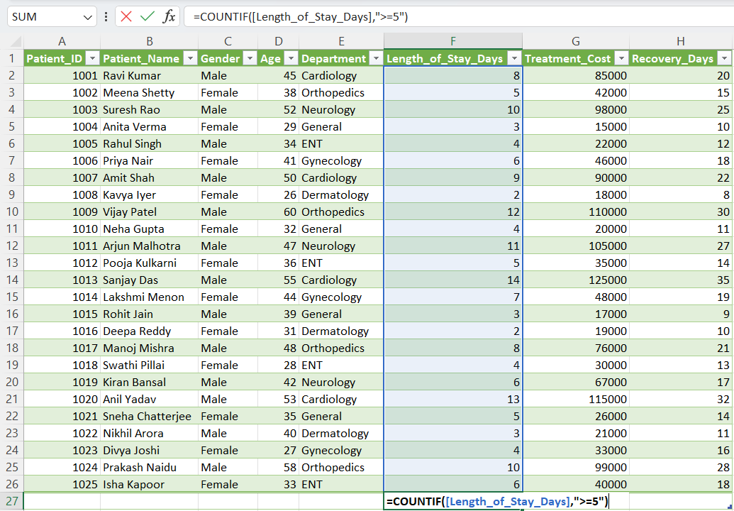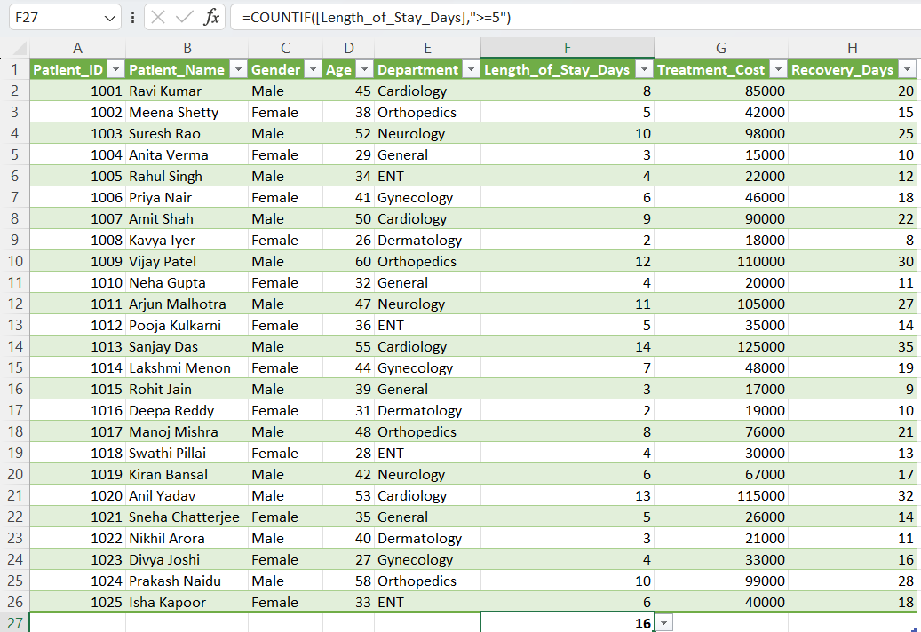

- Average cost for Female patients
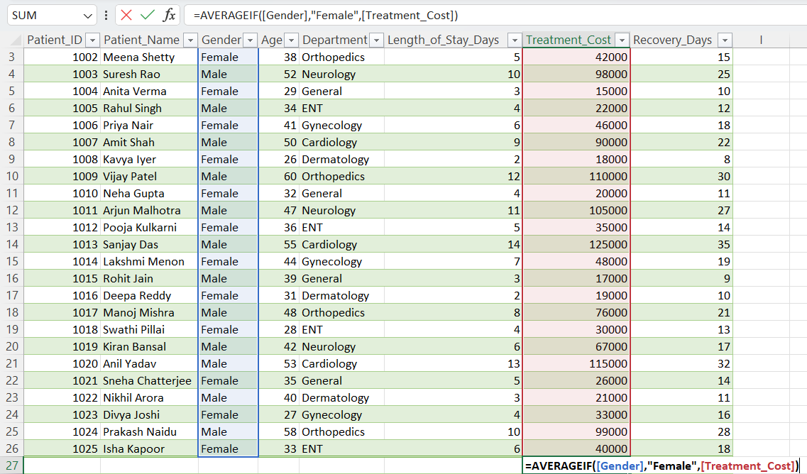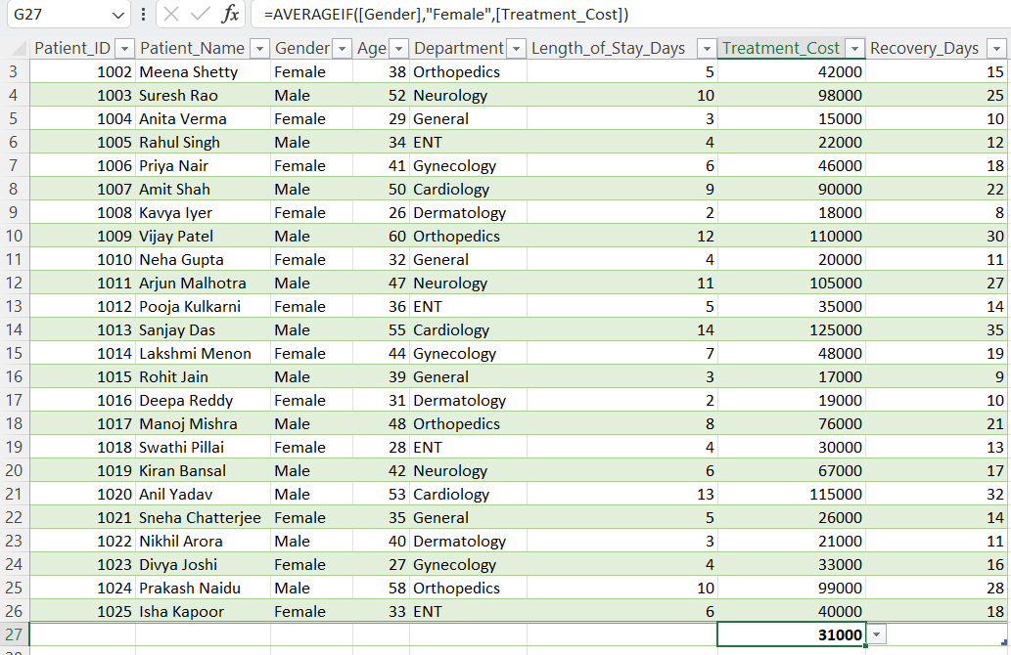
- PART 5: Text Functions (Healthcare Data Cleaning)
Task 9: Text Formatting
Convert names to Proper Case
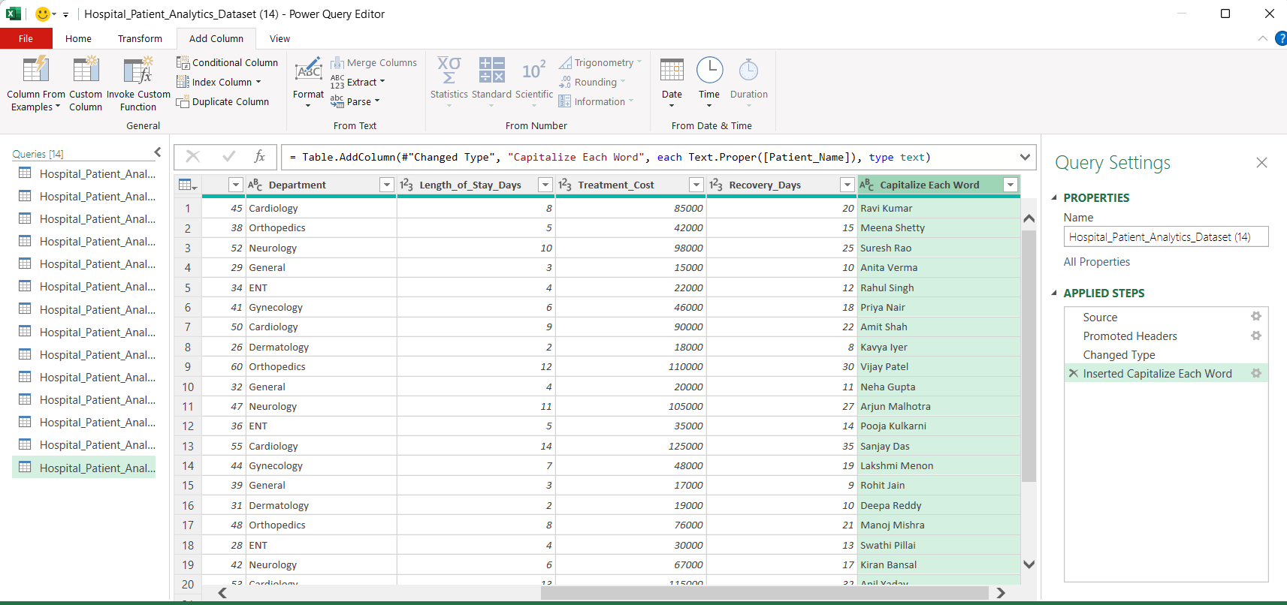
  - 2.Extract: First 4 letters → LEFT()
  - Middle name characters → MID()
  - Last 3 letters → RIGHT()
  - IN POWER QUERY:
  - 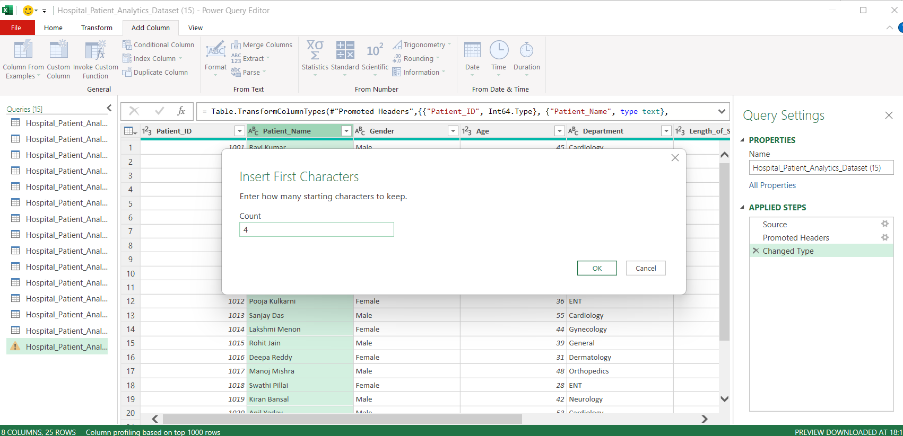

  - 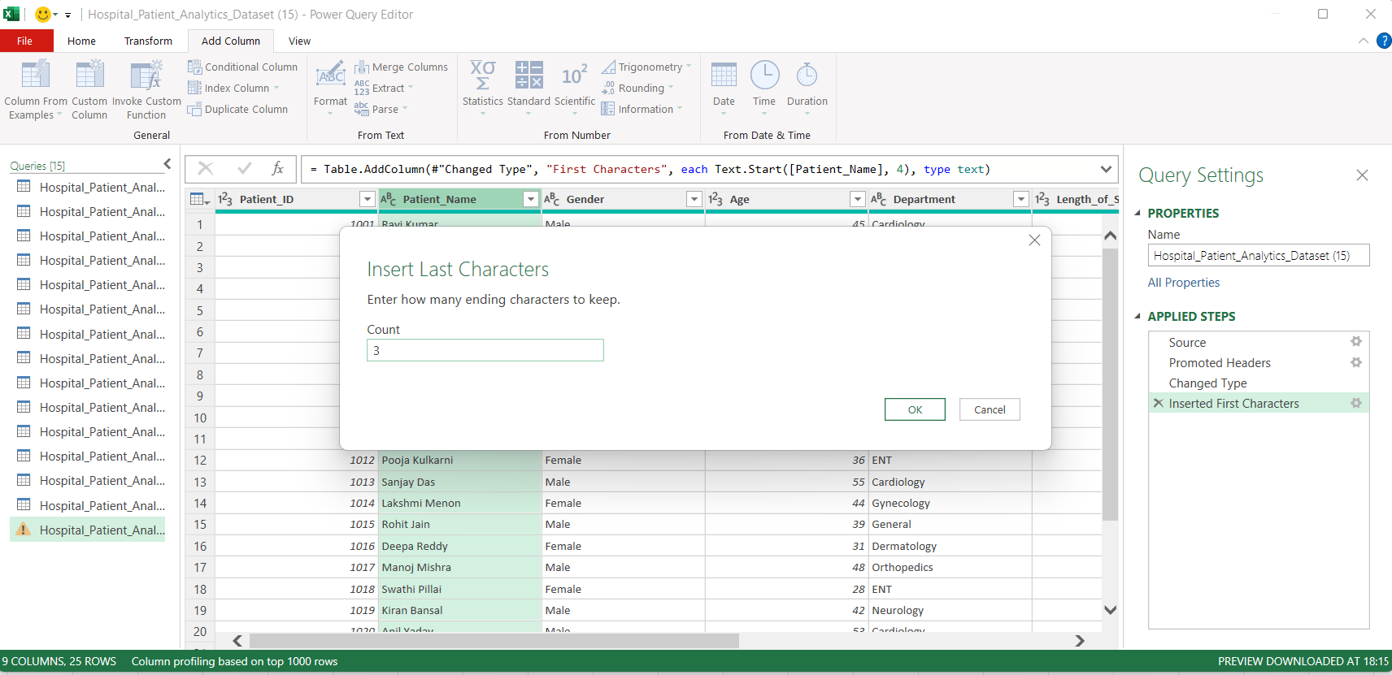
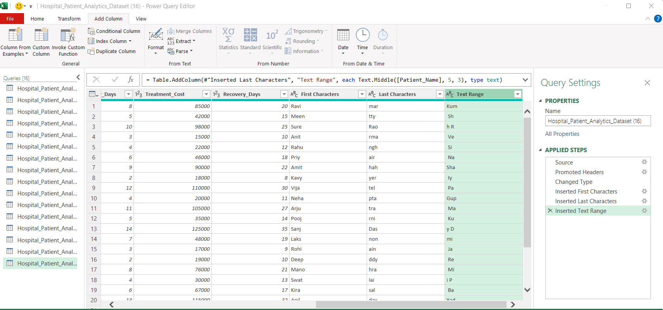
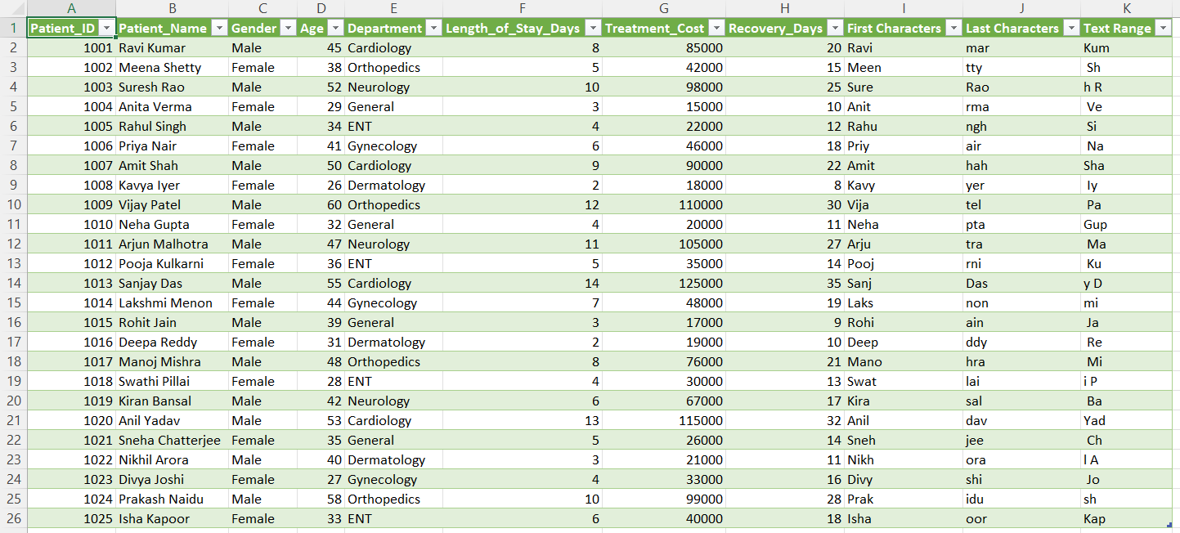
TEXT FUNCTIONS:

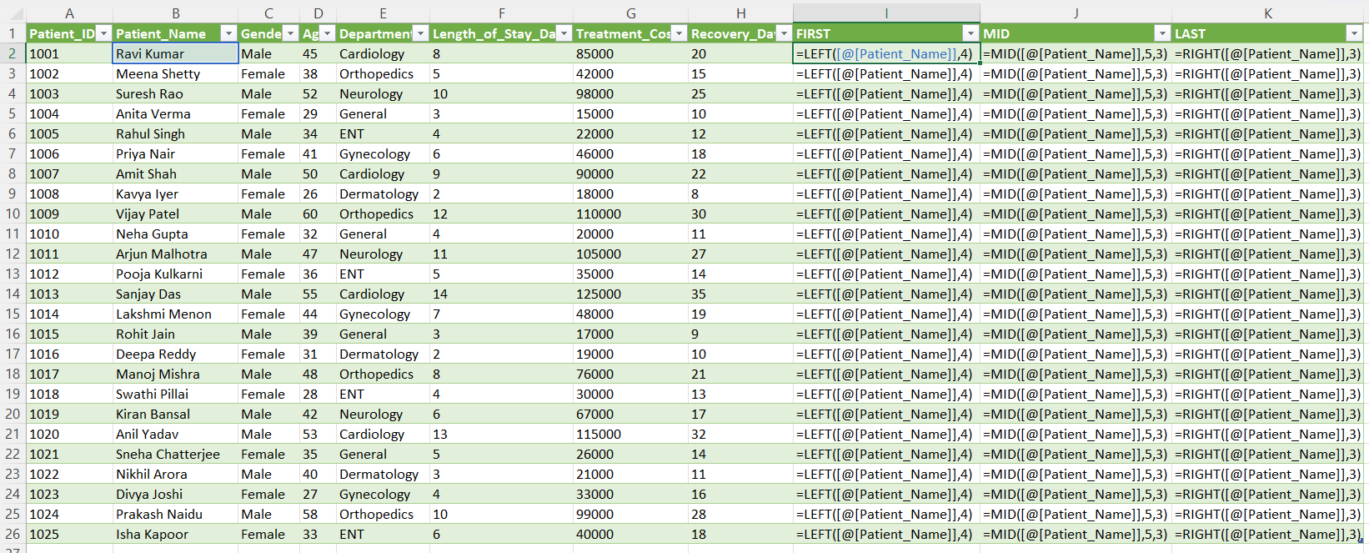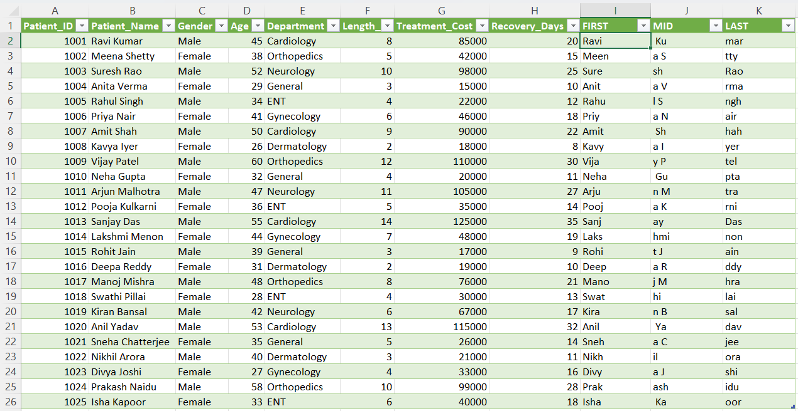
3.Convert Department names to: Uppercase
  - Lowercase
  - IN POWER QUERY:
  - 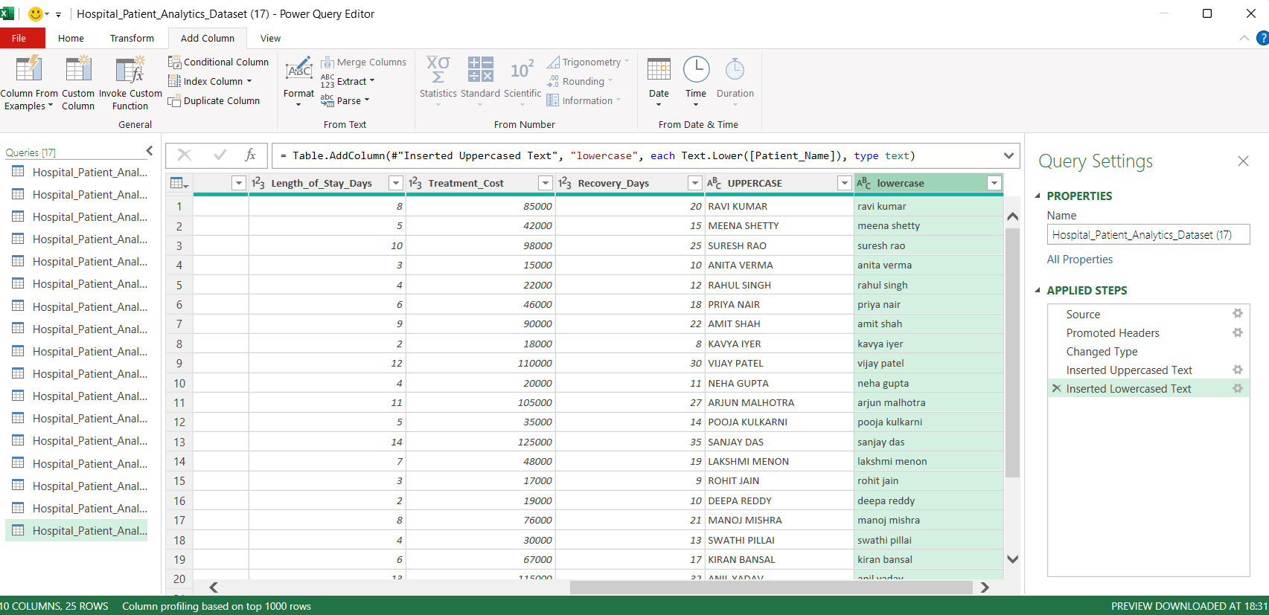
  - 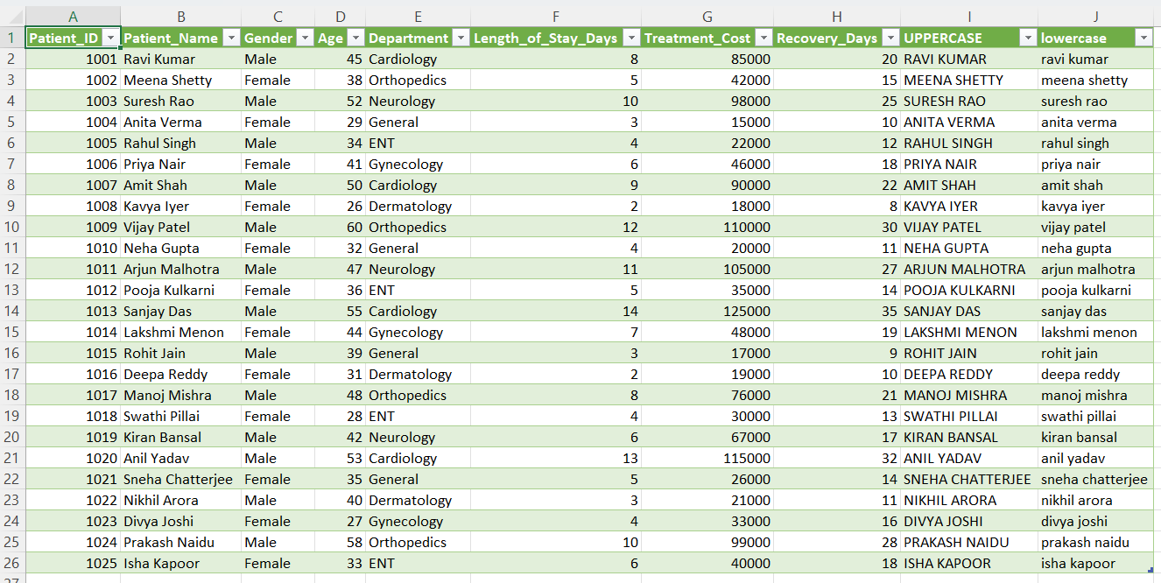

TEXT FUNCTIONS:
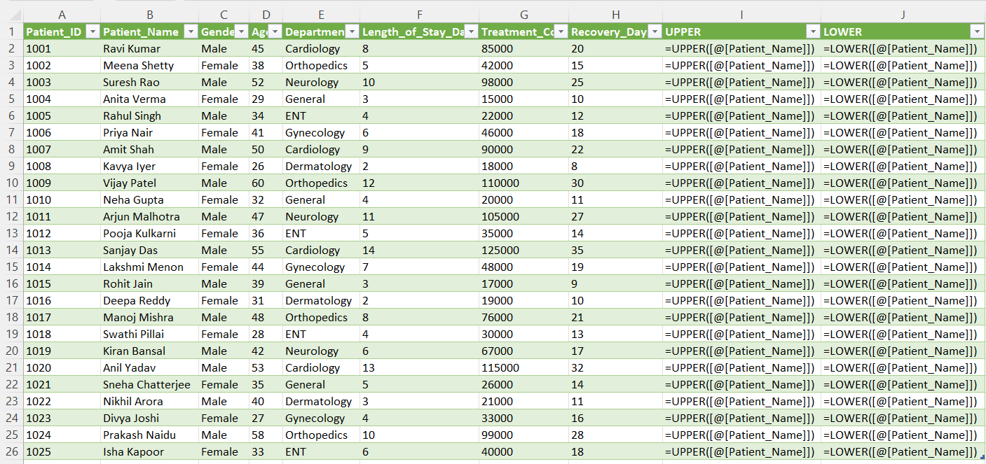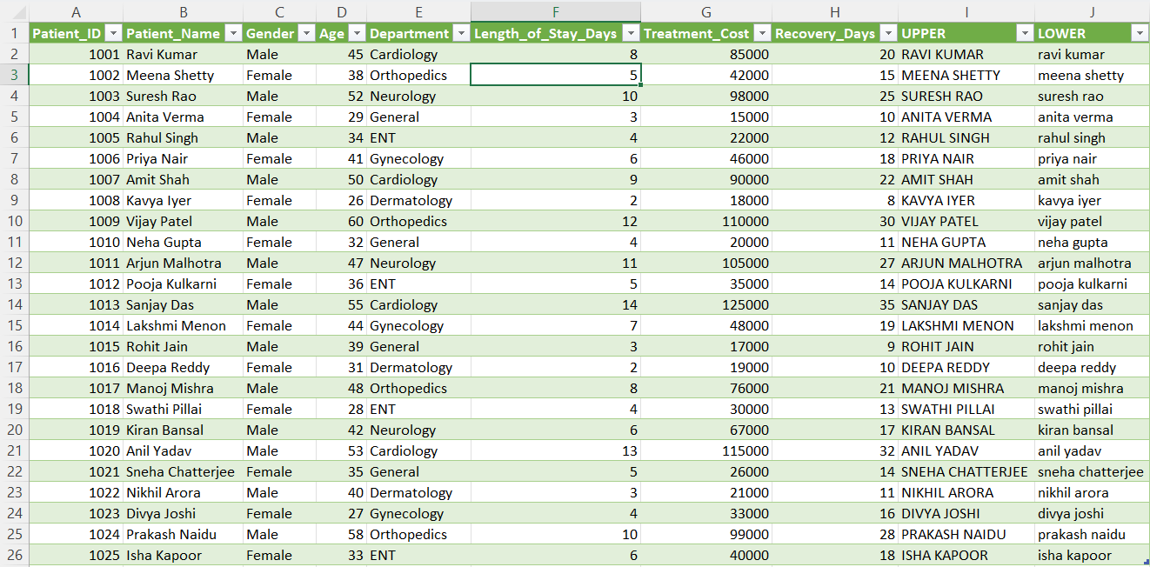

PART 6: Mini Case Study (Real-World)
Scenario:
Hospital management wants insights.
Tasks:
- Identify top 5 costliest treatments
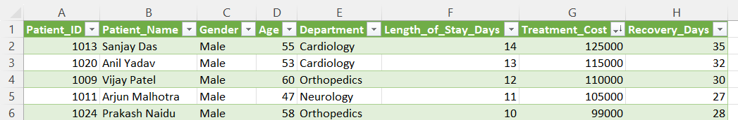
It is calculated by sorting the treatment costs by applying sort function of largest to smallest from the drop down menu.
- Find average treatment cost per department
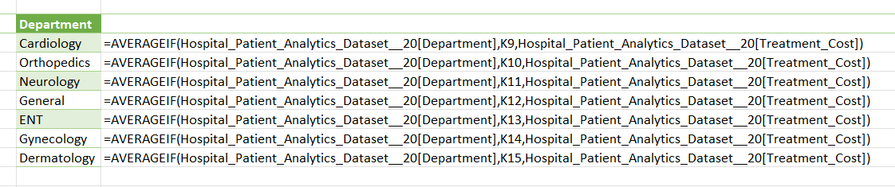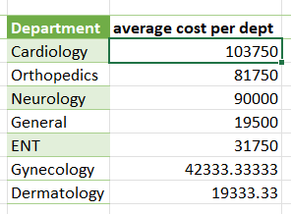

- Count patients per department
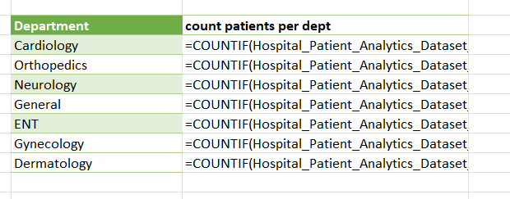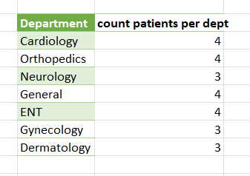

- Identify long-stay patients (>10 days)
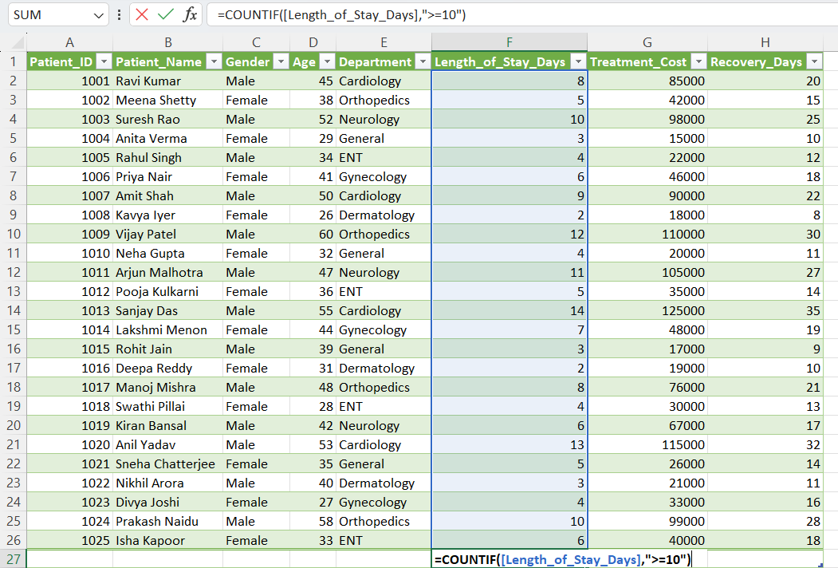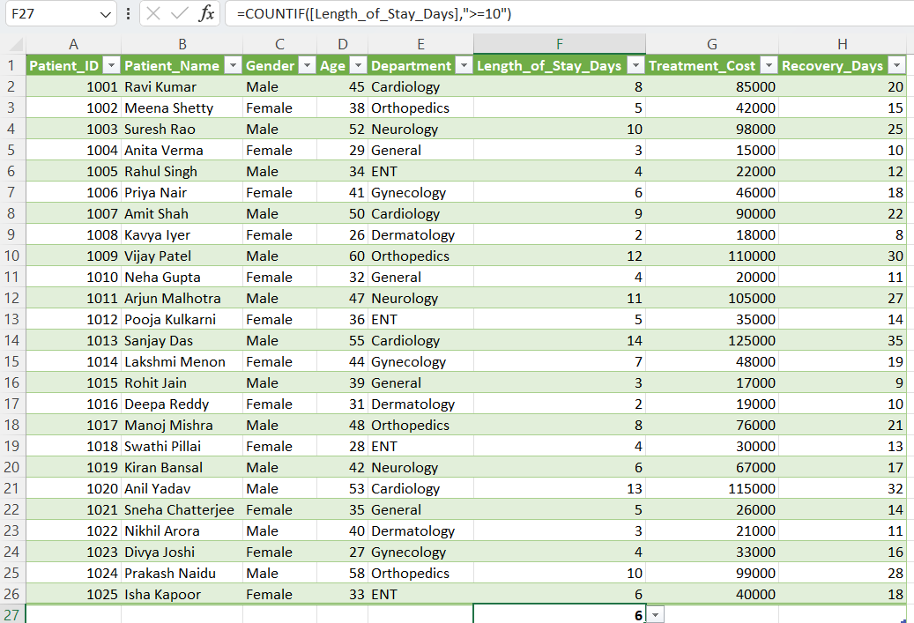

- Provide 3 actionable insights
a.Observation:
Cardiology, Orthopedics and Neurology have high treatment costs and longest stays.
Action:
- Review why treatment costs are high
- Review patients longest stay reasons
Benefit:
By reviewing, we can reduce hospital expenditure.
b.Observation:
general and dermatology departments have lower costs and low patient stay.
Action:
- Increase patient flow
- Make better promotions
- Make better revenue to increase profitability
Benefit:
With high patient volume with controlled costs profitability will increase.
c.Observation:
Patients staying more than 10 days increase hospital expenditure.
Action:
- Speed up lab reports
- Regular follow ups
Benefit:
More patients will visit and more beds will be available.

